**Plotting | Salting | Smoothing**

**Quadratic Function: ax2 + bx + c**

**Java Plotting**

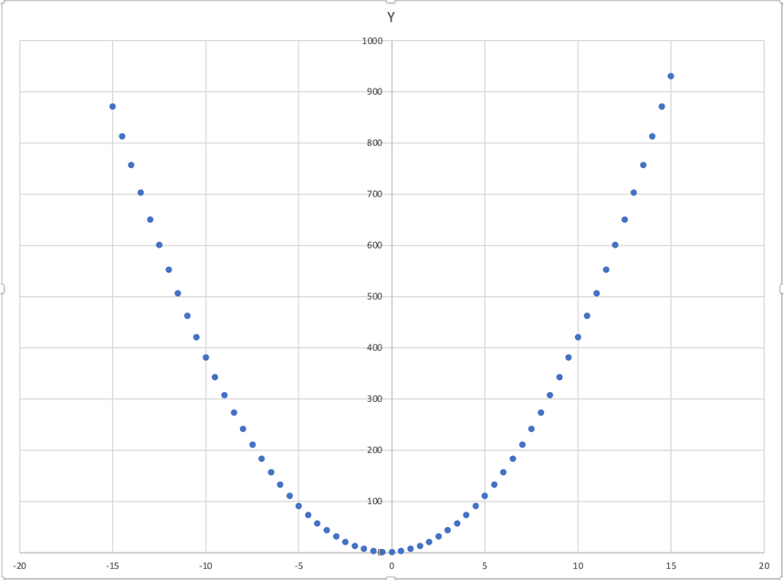

**Plotting using Java for the Quadratic Function**

**Java Salting**

**Salting using Java for the Quadratic Function (Salt Range = 25)**

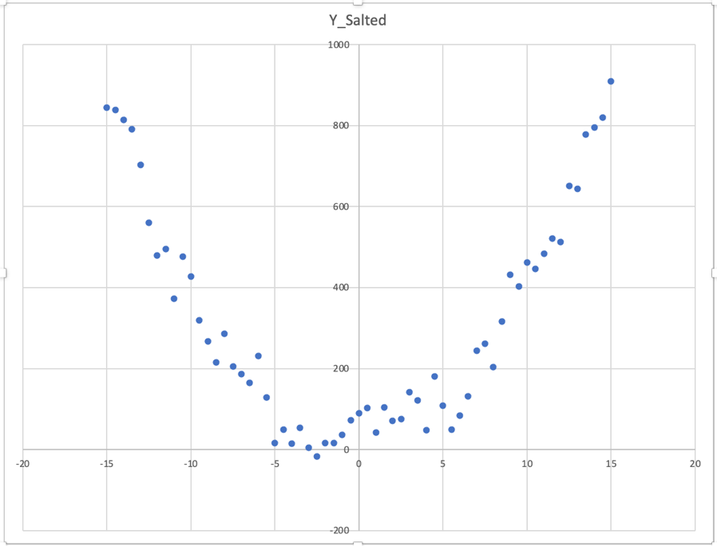

**Salting using Java for the Quadratic Function (Salt Range = 100)**

**Java Smoothing**

**Smoothing using Java for the Quadratic Function (1st Run of Smoothing)**

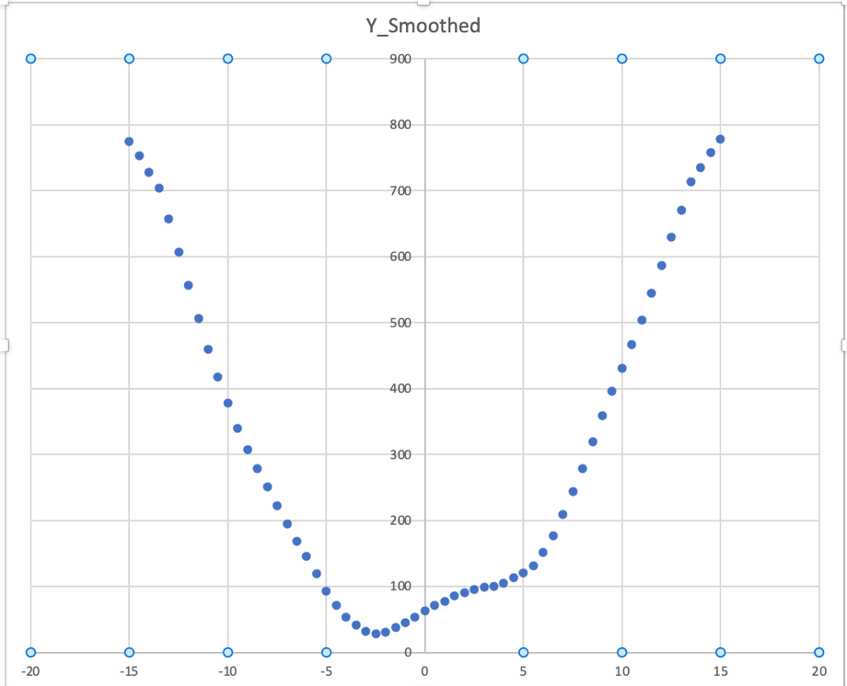

**Smoothing using Java for the Quadratic Function (2nd Run of Smoothing)**

**Smoothing using Java for the Quadratic Function (3rd Run of Smoothing)**

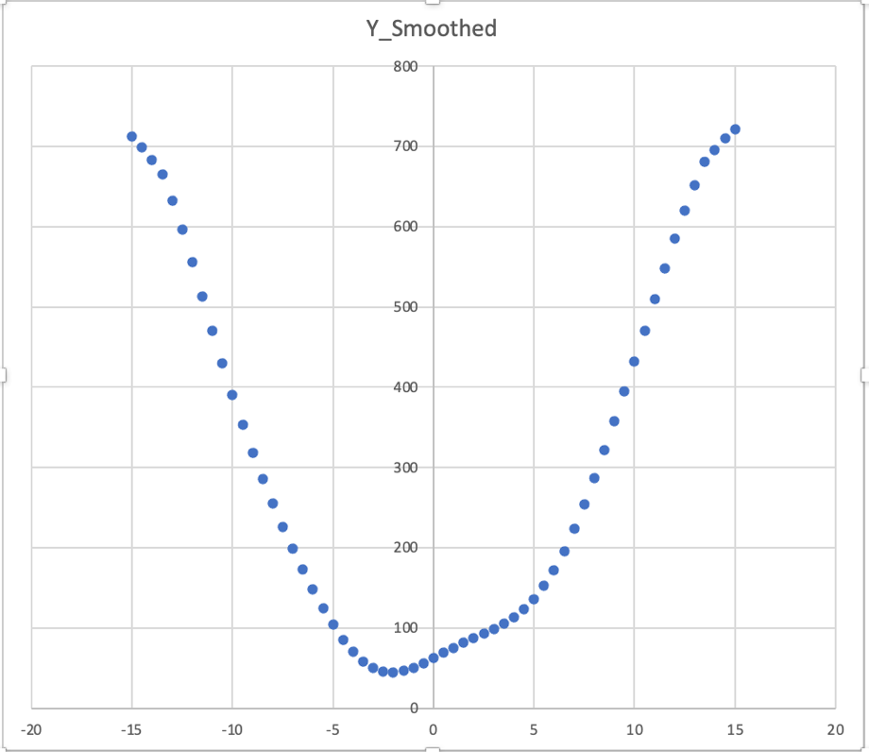

**Smoothing using Java for the Quadratic Function (4th Run of Smoothing)**

**Octave Plotting**

**Plotting using Octave for the Quadratic Function**

**Octave Salting**

**Salting using Octave for the Quadratic Function**

**Octave Smoothing**

**Smoothing using Octave for the Quadratic Function**

**Smoothing using Octave for the Quadratic Function (2nd and 3rd Run)**

**JFreeChart Plotting**

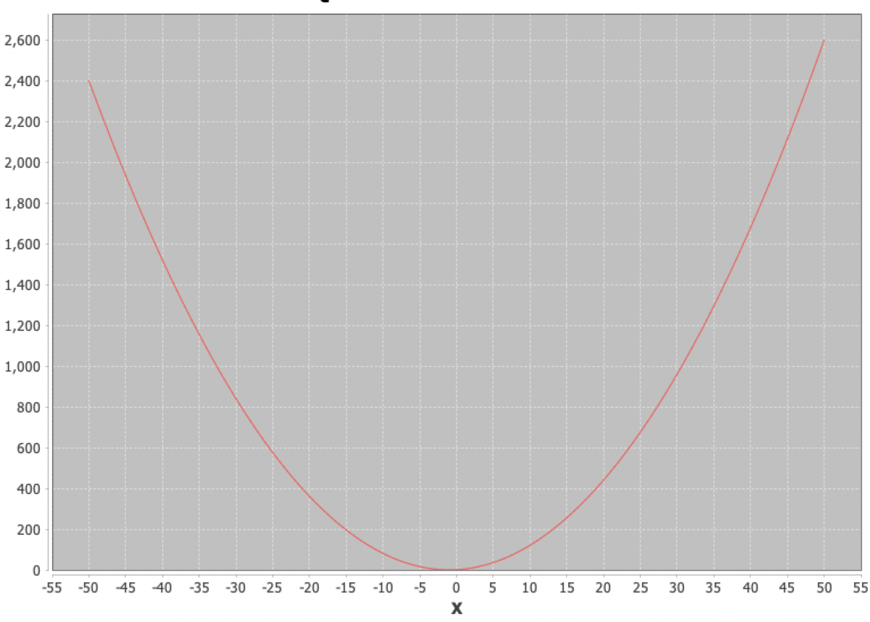

**Plotting using JFreeChart for the Quadratic Function**

**JFreeChart Salting**

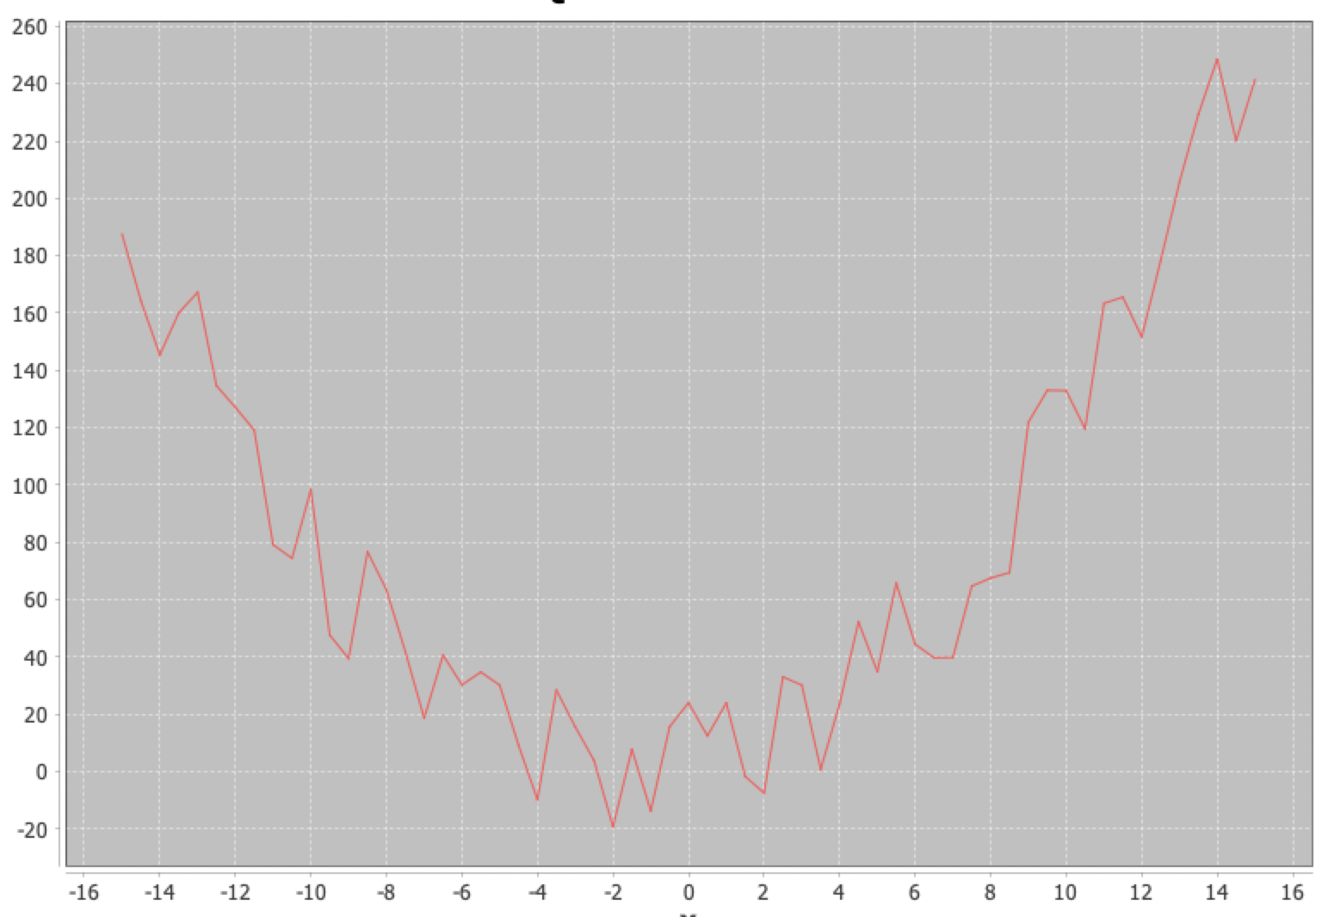

**Salting using JFreeChart for the Quadratic Function**

**JFreeChart Smoothing**

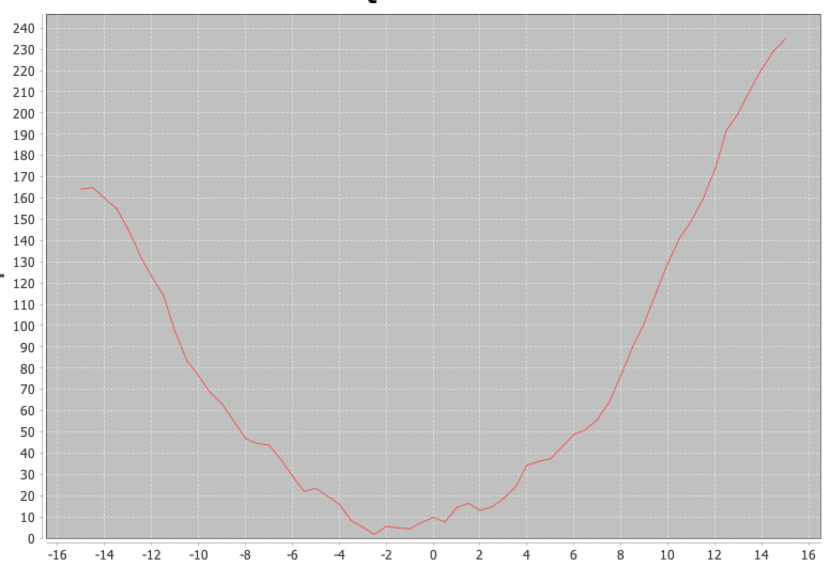

**Smoothing using JFreeChart for the Quadratic Function**